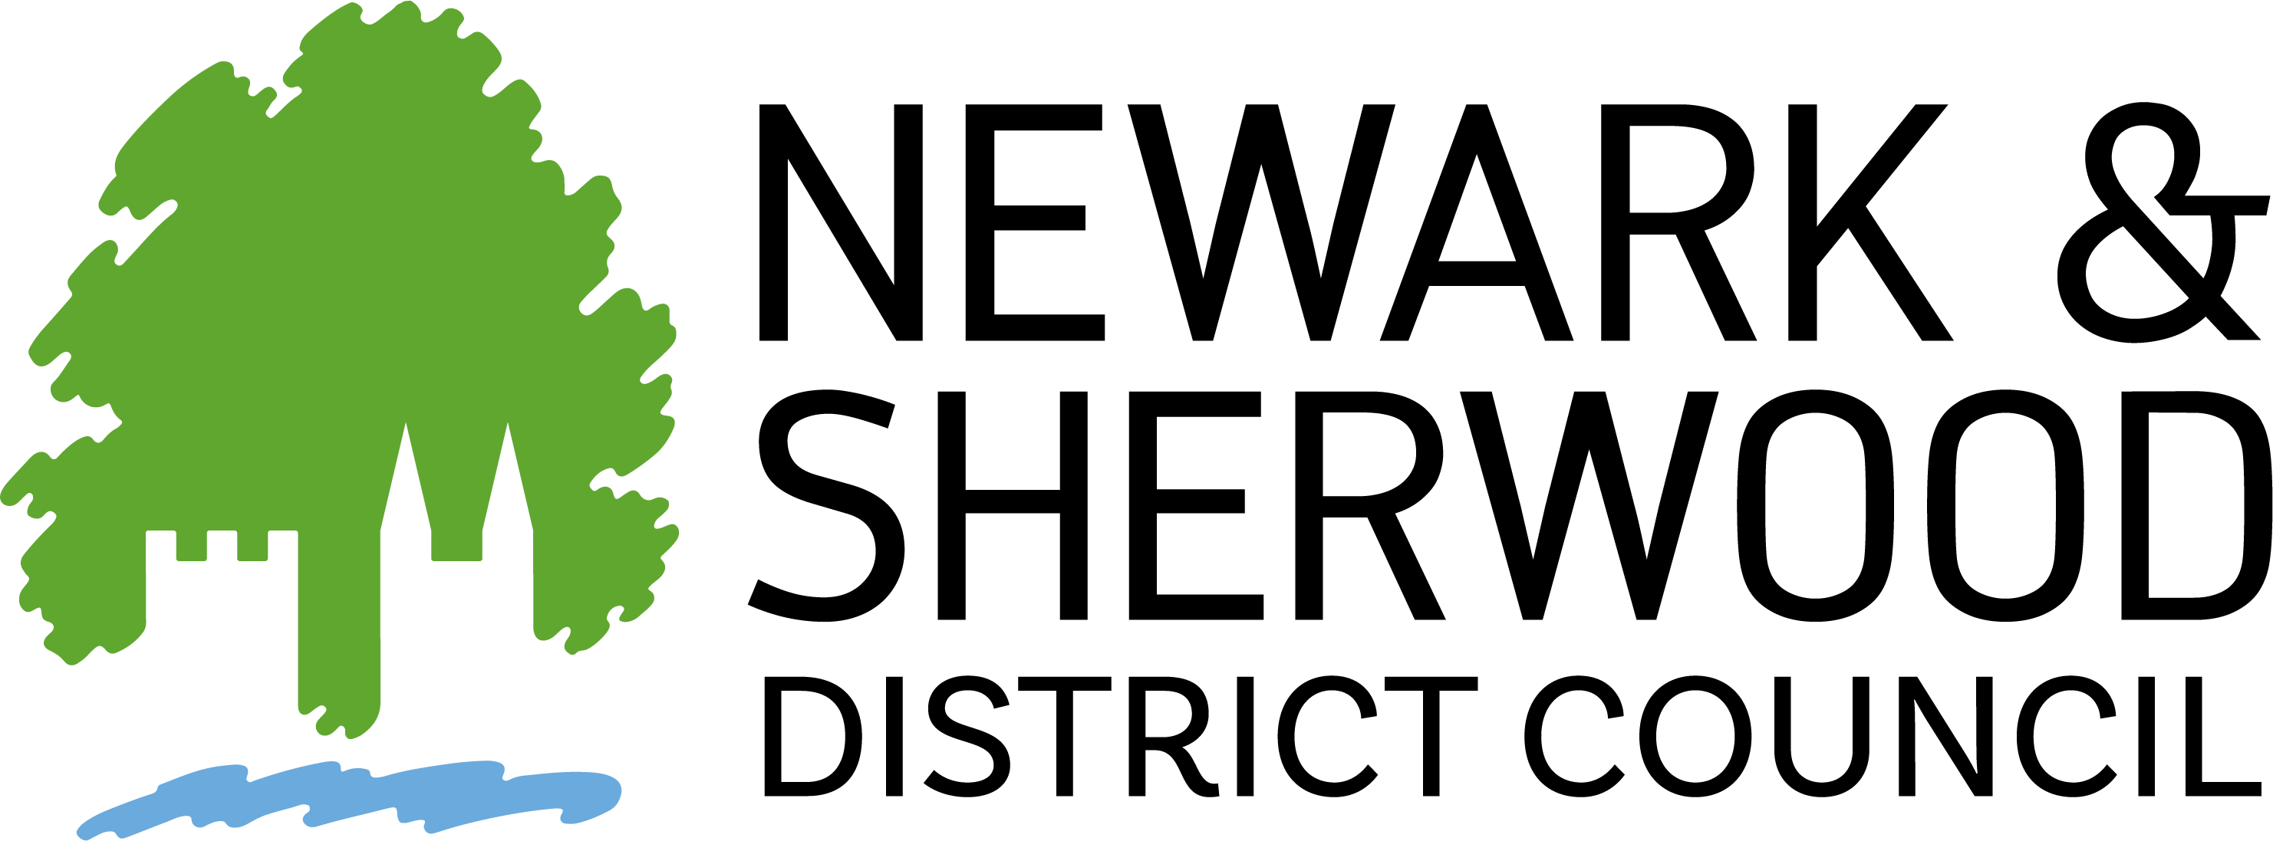
Local Area Improvement Funds – Application Form

For Town and Parish Parks Legacy Fund and Environmental Improvement Grant

1. Applicant Information
Organisation
Contact name
Role/position
Address
Postcode
Telephone
Email
Which Grant are you applying for? (circle) | Play Area Improvement Fund | Play Area Improvement Grant AND Environmental Improvement Grant
How did you hear about the grant(s)?
Have you received advice regarding this application?

2. Supporting Documents Checklist
Document | Mandatory? | Attached (Y/N)
Constitution or governing document | Yes
Most recent financial statement, including Community Infrastructure Levey (CIL)- if applicable | Yes
Recent bank statement(s) | Yes
Site plan/map | Yes
Ward Councillor endorsement | Yes
Photos of existing area | Yes
Community feedback/consultation notes | Recommended
Quotes or estimates | Essential
Additional supporting documents | Optional

3. Your Project
Please use the following headings as a guide for your application. We recommend no more than 150 words per section. Not all sections may be applicable to your project.
Town and Parish Parks Legacy Fund
Project title
Why is this project needed?
How does the proposal improve accessibility?
How does the proposal address safety of women and girls?
Does the project address a play provision shortfall?
Does your project address any health and safety compliance issues on your current play park.
Does your project address any health and safety compliance issues on your current play park.

Environmental Improvement Grant
Project title
Project description
Why is this project needed?
How does the proposal improve the area?

4. Consultation
Has any community engagement been undertaken?
If so, please attach a copy of that consultation.

5. Promotion and Publicity
How will you promote the project?
Do you agree to acknowledge NSDC support?

6. Sustainability
How will the project be maintained long-term?

7. Budget & Match Funding

Town and Parish Parks Legacy Fund
Item/activity | Total Cost Excluding VAT(£) | VAT (£) | Amount requested (£) | Match funding source

Environmental Improvement Grant
Item/activity | Total Cost Excluding VAT(£) | VAT (£) | Amount requested (£)
Is your organisation VAT registered?
VAT Registration Number
Will you reclaim VAT using VAT126?
If not, why?

8. Other Supporting Information
Please include any other supporting information below or attach supporting documentation.

9. Bank Details

Account name
Account number
Sort code

10. Declaration

I confirm that the information in this application is accurate to the best of my knowledge. I agree to abide by the terms and conditions of the funding body, declare any conflicts of interest, and ensure the project complies with all ethical and financial regulations
Signed
Name
Position
Date

Data Protection Statement
Newark and Sherwood District Council will only process any personally identifiable information that you provide in accordance with our responsibilities under the UK General Data Protection Regulation (UK GDPR) and the Data Protection Act 2018. Further details of how the Council will manage your personal information are contained within the Privacy Notice which can be found here www.newark-sherwooddc.gov.uk/privacynotice

